**HTML and CSS Report for COMSATS Non-Faculty Job Application Form**

This report details the design and functionality of the **COMSATS Non-Faculty Job Application Form**, which was created using HTML and CSS. The design incorporates form inputs, a table, and various formatting elements to create a structured and interactive form for job applicants.

**1. HTML Structure**

The HTML structure consists of several key sections:

* **HTML Metadata**: The page begins with the <!DOCTYPE html> declaration, setting the document type to HTML5. The lang attribute is set to "en" for English, and the meta tag for charset is set to "UTF-8" for encoding. There's also a meta tag for viewport settings to ensure mobile responsiveness.
* **Head Section**: In the head section, the <title> tag defines the page title as "Comsats Form", and the CSS file (style.css) is linked via the <link> tag.
* **Body Structure**: The <body> section contains two main containers (container and container2) that house the form's content and structure. A third smaller container (container3) is reserved for uploading a photo.
  + **Container (Header with Image and Title)**:
    - Includes a <div> that contains the **COMSATS University logo** and the **Form Title ("Non-Faculty Job Application Form")**.
  + **Container3**:
    - Reserved for the applicant’s photo upload, indicated by the text "Paste your Photo here".
  + **Container2 (Form Section)**:
    - This includes the main form where users will enter information such as:
      * **Post Applied For**, **Department**, and **Campus**
      * **Personal Information**: Name, Father’s Name, NIC, DOB, Gender, Address, etc.
      * 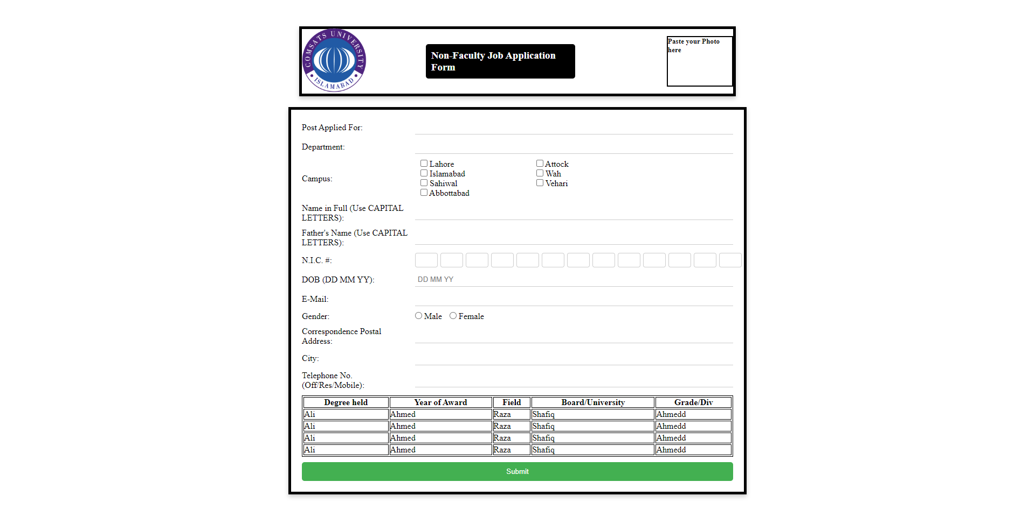**Academic Details**: Presented in a table format.

**2. CSS Design and Styling**

The CSS file (style.css) is linked to the HTML document to provide styling to the form elements. Key design elements include:

* **Global Styling (*)**: Resets margins and padding to ensure consistent rendering across browsers.
* **Body**:
  + Background color: White.
  + Display: Flexbox layout used to center content vertically and horizontally.
* **Containers**:
  + container: Styled with flexbox to align the **COMSATS logo** and **Title** side-by-side. It also has a black border and box-shadow for a clean and modern look.
  + container3: Reserved for the photo, styled with a border and placeholder text.
  + container2: Contains the form with a similar black border and shadow to maintain a consistent design across elements.
* **Form Elements**:
  + **Labels** and **Inputs**: Labels are aligned to the left with some padding, and inputs have bottom borders and change color on focus.
  + **NIC Input**: Consists of small input boxes to replicate the format of the NIC.
  + **Campus Options**: Flexbox is used to ensure proper alignment of checkboxes.
* **Table**:
  + Simple border for the academic table, ensuring all cells are neatly divided.

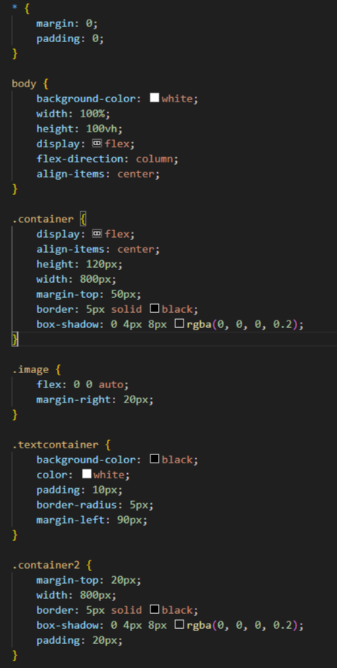

**3. Functionality**

The form has required fields such as **Post Applied For**, **Name in Full**, **Father’s Name**, and **Email**, ensuring that users cannot submit the form without providing this key information.

Additional features include:

* **Radio Buttons** for gender selection.
* **Checkboxes** for campus selection.
* **Table** for educational qualifications, though placeholder data ("Ali", "Ahmed", etc.) should be replaced with user inputs.

**4. Areas to Insert Snapshot**

* You can upload a snapshot of the rendered output of the form after including the CSS and HTML in a browser.
* Highlight the following sections for the snapshot:
  + The **top section** showing the **COMSATS logo** and **Form Title**.
  + The **form fields** for post, department, and personal information.
  + The **table** for educational qualifications.

**Google Drive Link**: https://drive.google.com/drive/folders/1tK0O25hK0_1WUQWrU1xrOWUMHFj5pmbb?usp=drive_link